Experiment- 18

Write a LEX program to count the number of Macros defined and header files included in the C program.
Code:
%{
#include <stdio.h>
int macros=0, headers=0;
%}
%%
^[ \t]*#define\b { macros++; }
^[ \t]*#include\b { headers++; }
.|\n ;
%%
int main(){ yylex(); printf("Macros: %d\nHeaders: %d\n", macros, headers); return 0; } int yywrap(){ return 1; }
Output:
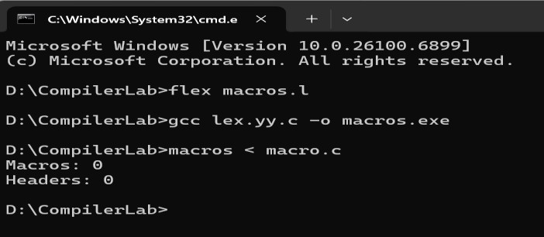

Experiment- 19
Write a LEX program to print all HTML tags in the input file. Code:
%{
#include <stdio.h>
%}
%%
\<[^>]+\> { printf("HTML Tag: %s\n", yytext); }
.|\n ;
%%
int main(){ yylex(); return 0; } int yywrap(){ return 1; } Input:
<html>
<body>
<h1>My First Heading</h1>
<p>My first paragraph.</p>
</body>
</html>
HTML Tag: <html> HTML Tag: <body> HTML Tag: <h1>
HTML Tag: </h1> HTML Tag: <p>
HTML Tag: </p> HTML Tag: </body> HTML Tag: </html>

Output:
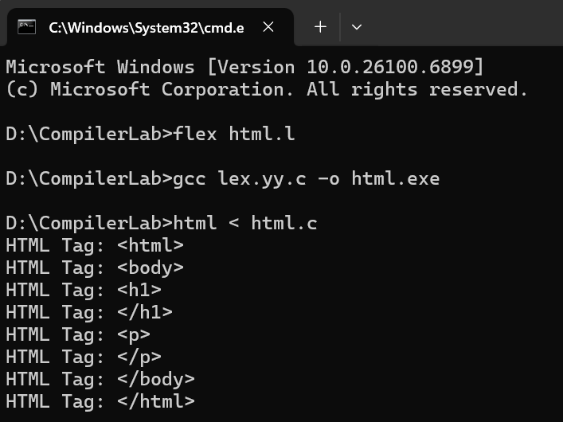

Experiment- 20
Write a LEX program which adds line numbers to the given C program file and display the same in the standard output.
Code:
%{
#include <stdio.h> int lineno = 1;
%}
%%
[^\n]*\n { printf("%4d: %s", lineno++, yytext); } [^\n]+ { printf("%4d: %s\n", lineno++, yytext); }
%%
int main(){ yylex(); return 0; } int yywrap(){ return 1; } Output:
#define PI 3.14 #include<stdio.h> void main()
{
printf("hello");
}
cpp

Copy code
1: #define PI 3.14
2: #include<stdio.h>
3:
4: void main()
5: {
6: printf("hello");
7: }

Output:
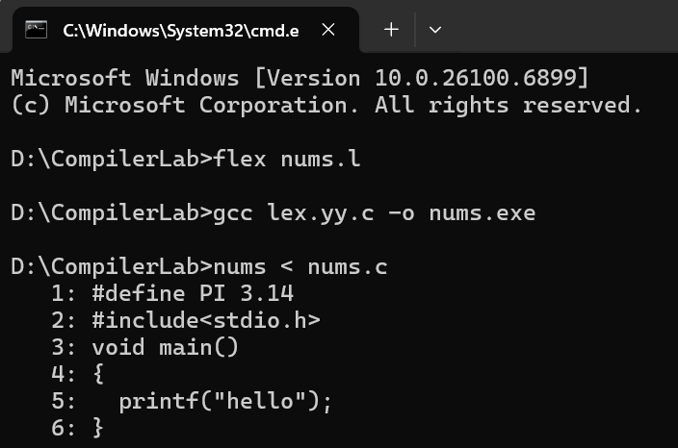

Experiment- 21
Write a LEX specification count the number of characters, number of lines & number of words.
Code:
%{
#include <stdio.h>
int chars=0, words=0, lines=0;
%}
%%
[ \t]+ ;
\n { lines++; chars++; }
[A-Za-z0-9_]+{ words++; chars += yyleng; }
. { chars += yyleng; }
%
int main(){ yylex(); printf("Chars:%d Words:%d Lines:%d\n", chars, words, lines); return 0;
}
int yywrap(){ return 1; }
Output:
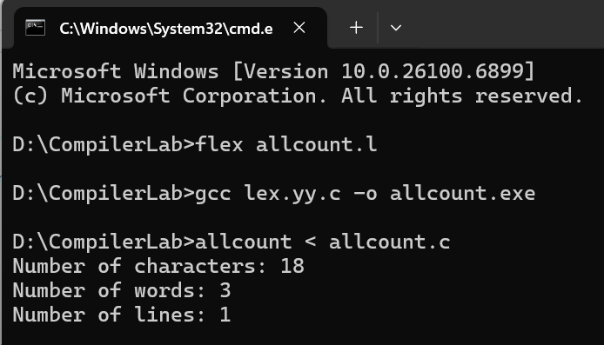

Experiment- 22
Write a LEX program to count the number of comment lines in a given C program and eliminate them and write into another file.
Code:
%{
#include <stdio.h> int comment_lines=0; FILE *out;
%}
%%
"//".* { comment_lines++; }
"/"*([^*]|\*+[^*/])*\*"/" { /* attempt to match block comment */ comment_lines++; } [^\n]+ { fprintf(out, "%s", yytext); }
\n { fprintf(out, "\n"); }
%%

int main(){ yyin = stdin;
out = fopen("output.c","w");
if(!out){ perror("output.c"); return 1; } yylex();
fclose(out);
printf("Comment lines: %d\nNon-comment code written to output.c\n", comment_lines); return 0;
}
int yywrap(){ return 1; } Output: #include<stdio.h>
int main()
{
int a; /*var declaration*/ printf("hi");
return 0;
}
Output:
